VICTORIA HIGHLAND GAMES & CELTIC FESTIVAL CLAN and SCOTTISH ORGANIZATION REGISTRATION

The 161st Victoria Highland Games & Celtic Festival takes place Saturday May 18 and Sunday May 19, 2024, at Topaz Park in the City of Victoria (corner of Blanshard and Finlayson Roads). Participation of your Clan or Scottish organization in the Games is very much appreciated.

On Friday May 17 between 7pm-10pm there will be a Games VIP Reception at the new Victoria Scottish Community Centre (1803 Admirals Road, Victoria), 2 members of each clan or Scottish organization are invited to attend. As is our custom now, we’d like to have a potluck breakfast in the clan area on Sunday morning. We will discuss details on the Saturday with those interested. We would also like to have a separate Clan gathering on Sunday, again depending on everyone’s schedule. We will again award medals for the Best Clan Displays with the help of our Chieftain of the Games.

The VHGA is pleased to provide site space and two admissions passes free of charge if your Clan or Scottish organization display is informational only. Tables may be ordered for a rental fee of $10.00 each per day and chairs will be provided free of charge (the number of chairs required must be indicated on your registration form). If you require a tent, please email Randy. Additional admission passes may be ordered online at our website through EVENTBRITE https://victoriahighlandgames.com/ Please indicate where you would like your free passes mailed.

The Scottish Heritage Village will be roughly located in the center of Topaz Park. We hope to have a setup like last year, a circle of tents accessible through a main gate, with an information booth in the center – this may be subject to change due to park improvements and last-minute Games layout changes.

Please contact Randy Stewart at appin@shaw.ca or (250) 884-2777 if you have any questions.

RESPONSIBILITIES DURING THE EVENT

- Clans and Scottish organizations are expected to attend their space for the full duration of the Games day(s).
- Set-up time is on May 18 and 19, only from 6:30 am to 8:30 am. Vehicles are not permitted on the field and must be unloaded and parked in the lot by 8:00 am. You may park in the lot nearest the Games site; however, these spaces are provided on a first come, first serve basis. We will have quads, dollies and volunteers available to help you setup.
- You must provide your own table coverings and sun/rain protection.
- You are responsible for removing your garbage.
- No long-term parking in the loading area, vehicles must be moved once unloaded/loaded.

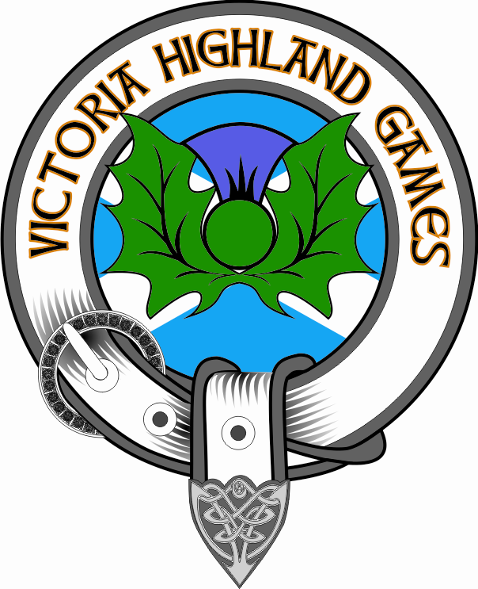

VICTORIA HIGHLAND GAMES & CELTIC FESTIVAL CLAN and SCOTTISH ORGANIZATION REGISTRATION

Please return this registration form to: VHGA, Clan/SO Registration
1149 Hampshire
Victoria, BC V8S 4T1 Canada

DEADLINE FOR REGISTRATION IS April 26, 2024.

Name of Clan/SO: ___________________________________________________________________________

Contact Person: ______________________________________________________________________________

Address: ______________________________________________________ Postal/Zip Code: ______________

Phone #: ____________________________________________ Email: ________________________________

Please add any notes here you may have for the organizers: _____________________________________________________________________________________________________________________________________________________________________________________________________________________________________________________________________________________________

Please check Day(s) attending ____ Both Sat/Sun ____ Sat (May 18) Only ____Sun (May 19) Only

Number of attendees at VIP reception (maximum of 2) _______
Number of tables required: _______ x $10.00/day = $_______

Number of chairs required: _______ Free

TOTAL ENCLOSED: $________

Please make any cheque payable to: Victoria Highland Games Association or VHGA. U.S. fees must be paid at par using either a money order in Canadian funds, or a cheque in U.S. funds.

WAIVER:

I have read and understand the rules and regulations and wish to participate as a Clan or Scottish organization at the Victoria Highland Games & Celtic Festival. I hereby for myself, my heirs, executors, and assigns waive and release any and all rights and claims I may have for damages against the Victoria Highland Games Association, its agents or representatives for any injuries which may be suffered by me during the Highland Games & Celtic Festival sponsored by said Association and/or any function related to the Highland Games & Celtic Festival.

Signature: ________________________________________ Date: ______ /________/2024

